**JAVA SWING BASED –STUDENT DISTRESS MANAGEMENT SYSTEM- SQL**

**CONNECTIVITY USING JDBC**

*A*

*Report*

*Submitted in partial fulfillment of the*

*Requirements for the award of the Degree of*

**BACHELOR OF ENGINEERING IN**

**INFORMATION TECHNOLOGY**

**By**

**S.Gourimanasa <1602-20-737-014>**

**Under the guidance of Ms B. Leelavathy**



**Department of Information Technology**

**Vasavi College of Engineering (Autonomous)**

**(Affiliated to Osmania University) Ibrahimbagh, Hyderabad-31**

**2020-2021**

# BONAFIDE CERTIFICATE

This is to certify that this project report titled

***‘Student distress management system’***

is a project work of **S.Gourimanasa** bearing

roll no. 1602-20-737-014 who carried out this

project under my supervision in the IV semester for the academic year 2020- 2021

|  |  |
| --- | --- |
| Signature | Signature |
| External Examiner | Internal Examiner |
|  |  |

**STUDENT DISTRESS SUPPORT SYSTEM**

**ABSTRACT**

Student distress support system is a console based project that connects students suffering from stress with stress support system.Every student should be in the position to identify their stress from the stress categories . The counsellors are going to group students according to their stress and corresponding stress control measures are taken by performing activities.

**Requirement Analysis**

**List of Tables:**

-Students

-Counsellor

-Entertainment

-Sports

-Acadamic-activities

- Stress_categories

**List of Attributes with their Domain Types:**

Students

-student_id varchar2(20)

-student_name varchar2(20)

Counsellor

-coun_name varchar2(20)

-specialization varchar2(20)

-activity_done varchar2(20)

Entertainment

- student_id varchar2(20)

- category varchar2(20));

Sports

-student_id varchar2(20)

-name_of_sport varchar2(20)

-equipment varchar2(20)

Acadamic-activities

-student_id varchar2(15),

-no_of_backlogs number(15)

-no_of_extraclasses_perweek number(20)

Stress_categories

-student_id varchar2(15)

-exams varchar2(5)

-anxity varchar2(6)

-pressure varchar2(8)

-attendance varchar2(11)

- personals varchar2(11)

- workpressure varchar2(12))

**DESIGN**

**Entity Relationship Diagram**

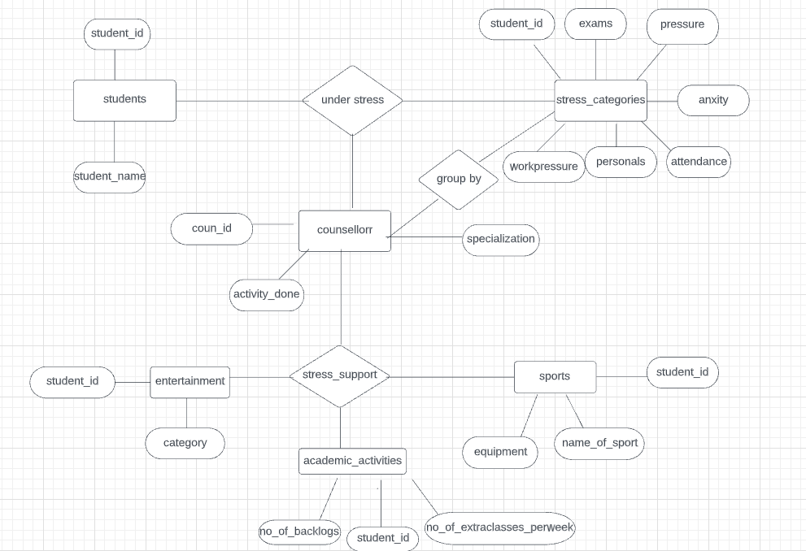

**DDL commands**

**TABLE 1:**

create table students(

student_id varchar2(20) primary key,

student_name varchar2(20));

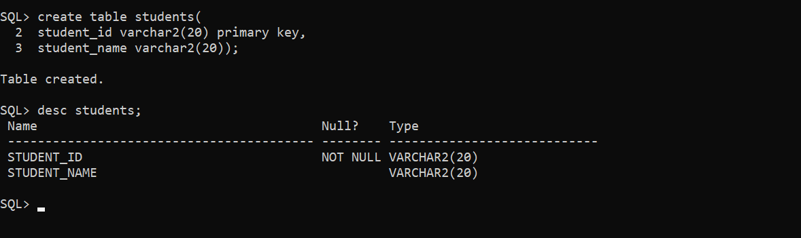

**TABLE 2:**

Create table counsellor(

coun_name varchar2(20)

specialization varchar2(20)

activity_done varchar2(20)

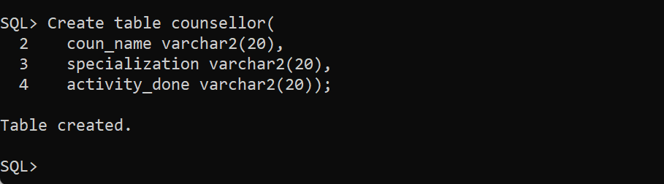

**TABLE 3:**

create table entertainment(

student_id varchar2(20),category varchar2(20));

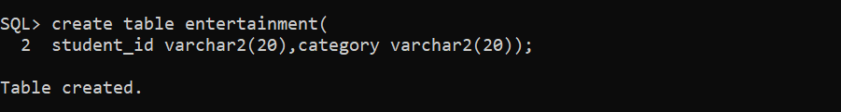

alter table entertainment add foreign key(student_id) references students;

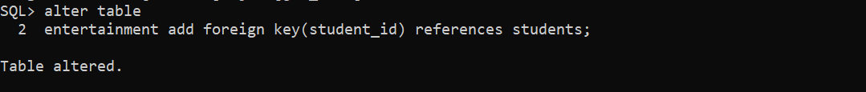

**TABLE 4:**

create table sports(

student_id varchar2(20),

name_of_sport varchar2(20),

equipment varchar2(20));

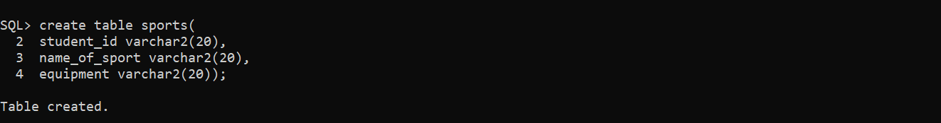

**TABLE-5:**

create table Acadamic_activities(

student_id varchar2(15),

no_of_backlogs number(15),

no_of_extraclasses_perweek number(20));

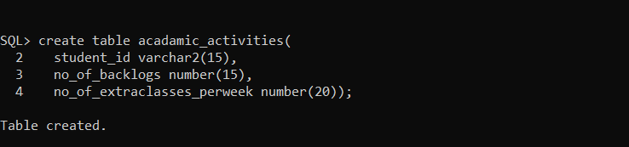

**TABLE-6:**

create table stress_categories(

student_id varchar2(20),

reason varchar(20));

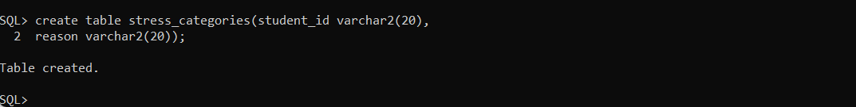

**DML COMMANDS**

1.insert into students values(&student_id,&student_name);

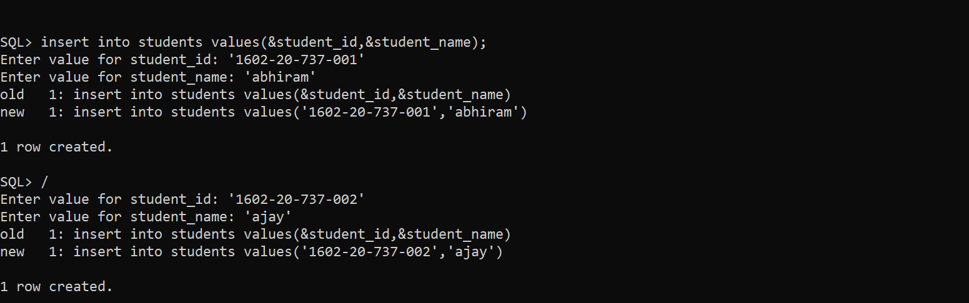

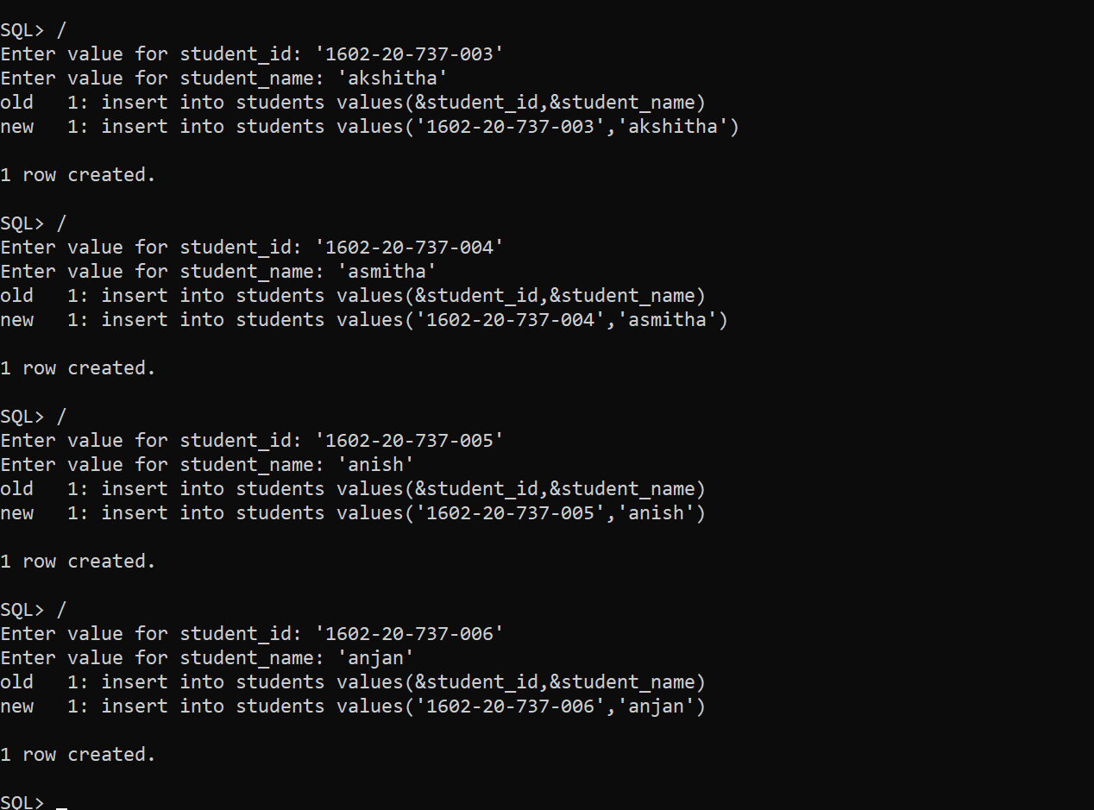

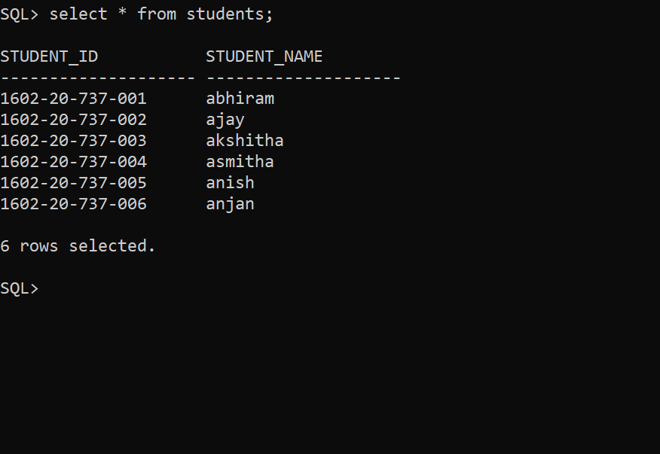

2. insert into stress_categories values('&student_id','&reason');

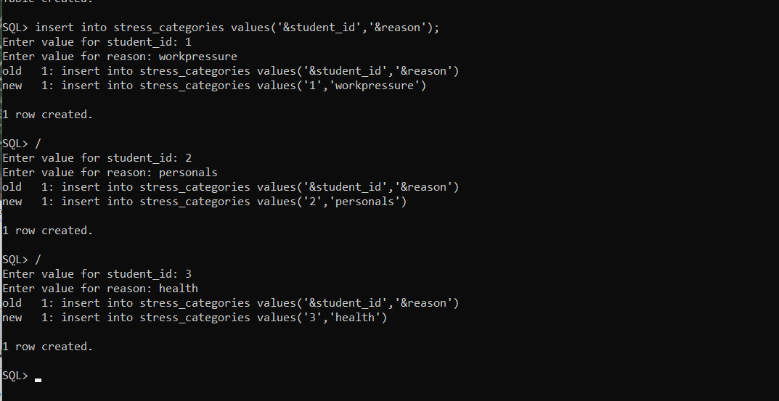

3. insert into sports values('&student_id','&name_of_sport','&equipment');

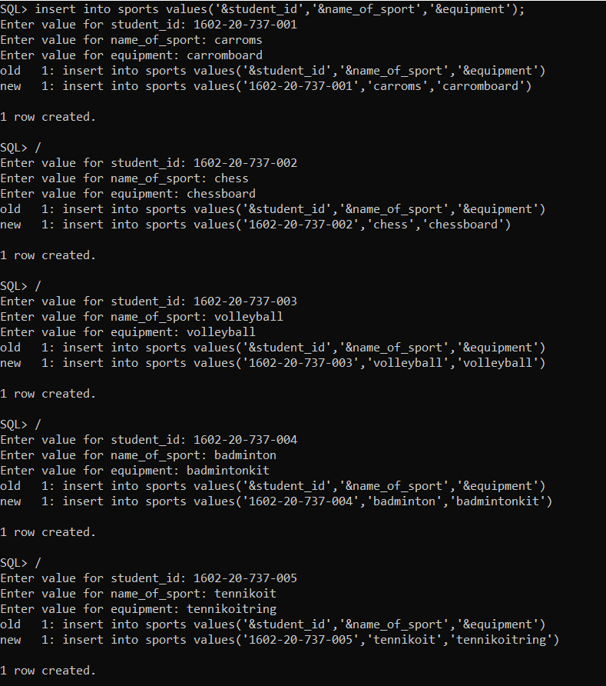

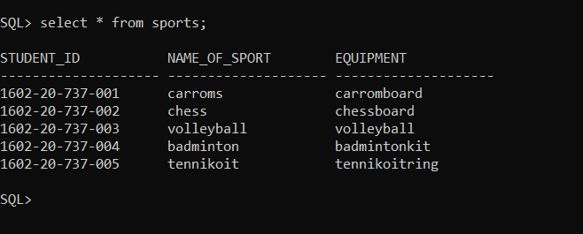

4. insert into entertainment values('&student_id','&category');

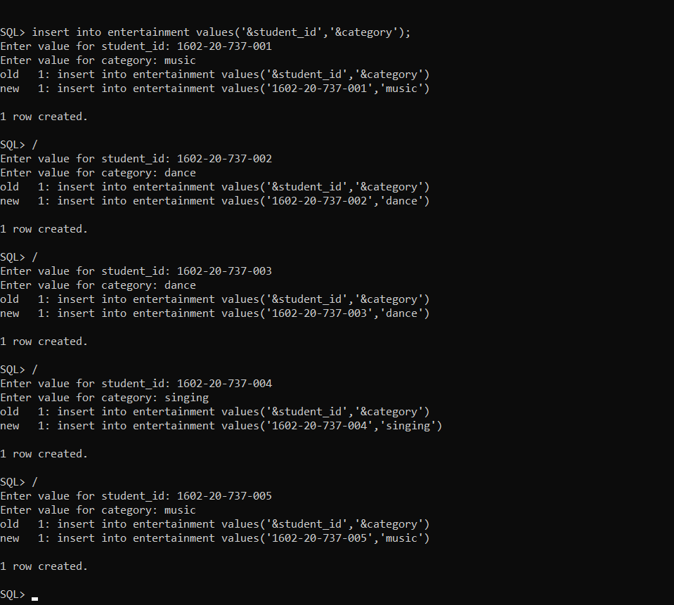

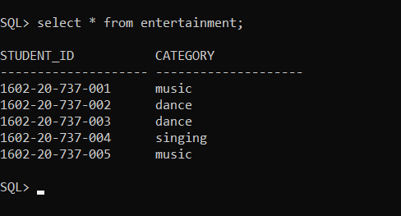

5. insert into acadamic_activities values('&student_id','&no_of_backlogs','&no_of_extraclasses_perweek');

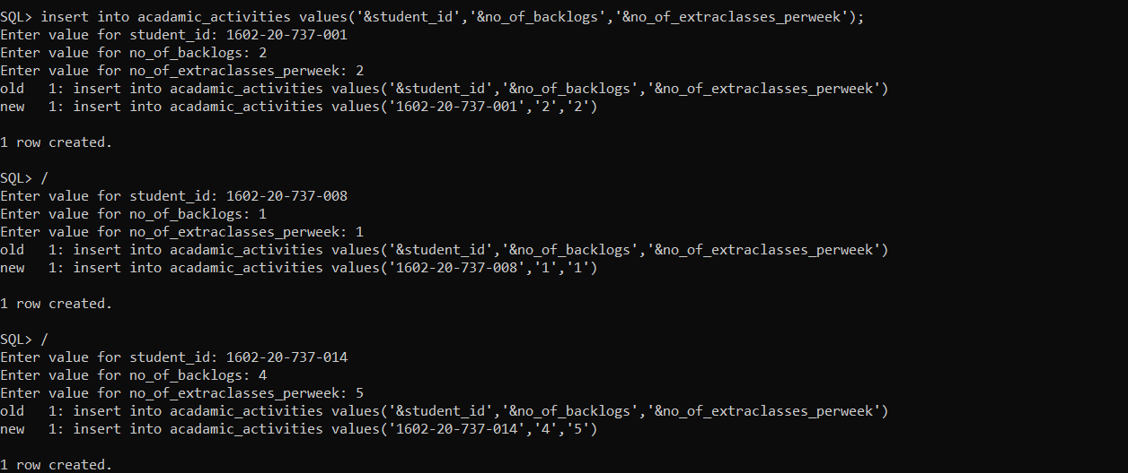

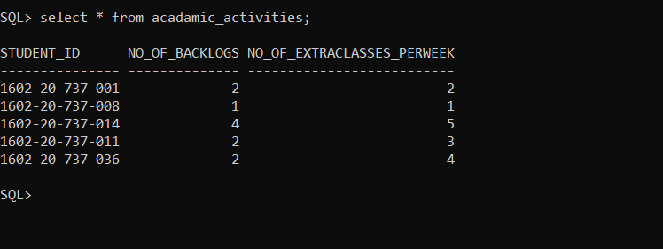

6. insert into counsellor values('&coun_name','&specialization','&activity_done');

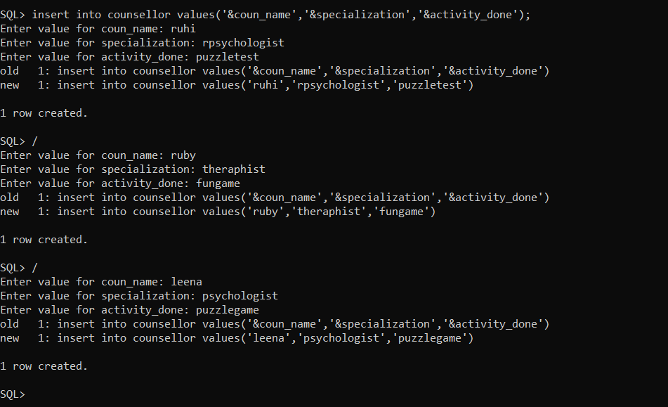

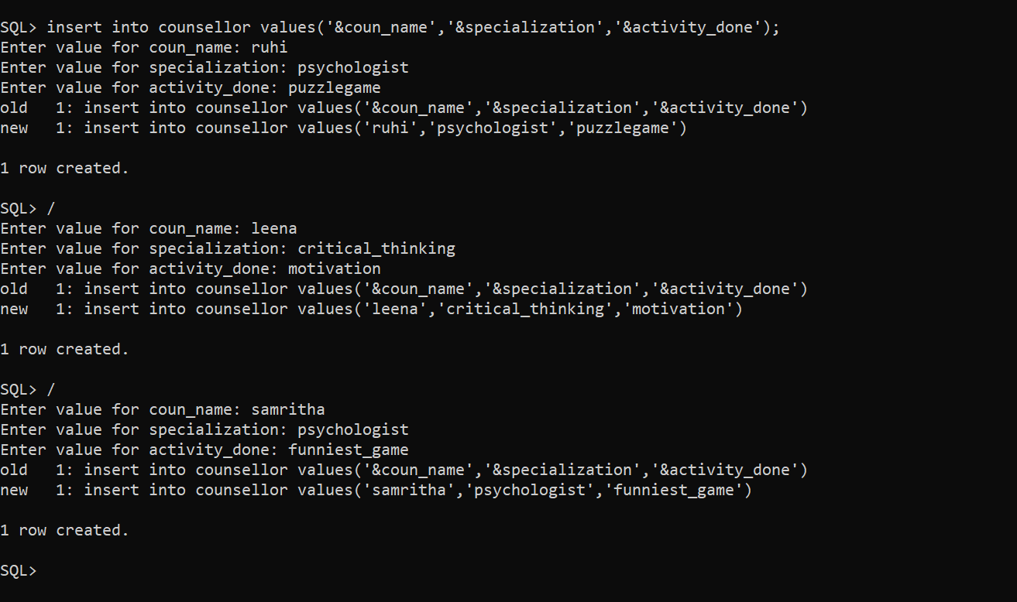

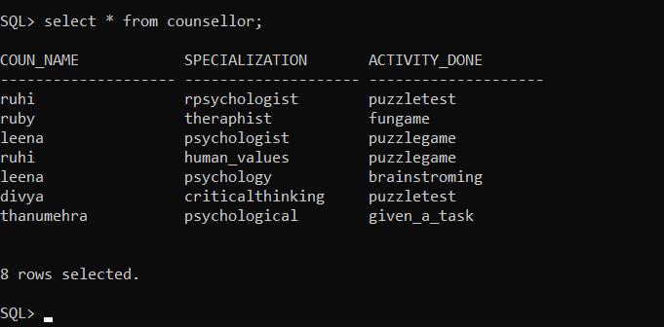

**IMPLEMENTATION**

**JAVA-SQL Connectivity using JDBC:**

**Java Database Connectivity (JDBC)** is an application programming interface (API) for the programming language Java, which defines how a client may access a database. It is a Java-based data access technology used for Java database connectivity. It is part of the Java Standard Edition platform, from Oracle Corporation. It provides methods to query and update data in a database and is oriented towards relational databases.

The connection to the database can be performed using Java programming (JDBC API) as:

import java.sql.Connection;

import java.sql.Driver;

import java.sql.DriverManager;

import java.sql.Statement;

private void jButton1ActionPerformed(java.awt.event.ActionEvent evt) {

Connection con =null;

try

{

Driver myDriver = new oracle.jdbc.driver.OracleDriver();

DriverManager.registerDriver( myDriver );

con = DriverManager.getConnection("jdbc:oracle:thin:@localhost:1521:XE", "manasa", "vasavi");

Statement stmt = con.createStatement();

String query= "INSERT INTO farmer VALUES(" + "'" +jTextField4.getText() + "',"+ "'" +jTextField2.getText() +"',"+"'"+ jTextField1.getText()+"')";

int i = stmt.executeUpdate(query);

System .out.println("Inserted ....");

stmt.close();

con.close();

}catch(Exception e){

System.out.println(e);

}

}

**Front-end Programs (User Interfaces) main**

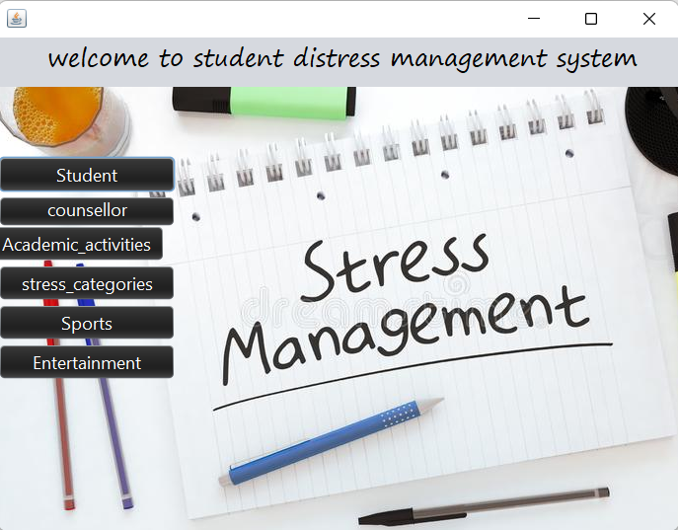

package student.distreess;

public class main extends javax.swing.JFrame {

public main() {

initComponents();

}

private void initComponents() {

jPanel1 = new javax.swing.JPanel();

jLabel1 = new javax.swing.JLabel();

jButton1 = new javax.swing.JButton();

jButton2 = new javax.swing.JButton();

jButton3 = new javax.swing.JButton();

jButton4 = new javax.swing.JButton();

jButton5 = new javax.swing.JButton();

jButton6 = new javax.swing.JButton();

jLabel2 = new javax.swing.JLabel();

jLabel3 = new javax.swing.JLabel();

jLabel1.setText("welcome to student distress management system");

jLabel1.setToolTipText("");

jLabel1.setBorder(javax.swing.BorderFactory.createBevelBorder(javax.swing.border.BevelBorder.RAISED));

javax.swing.GroupLayout jPanel1Layout = new javax.swing.GroupLayout(jPanel1);

jPanel1.setLayout(jPanel1Layout);

jPanel1Layout.setHorizontalGroup(

jPanel1Layout.createParallelGroup(javax.swing.GroupLayout.Alignment.LEADING)

.addGroup(javax.swing.GroupLayout.Alignment.TRAILING, jPanel1Layout.createSequentialGroup()

.addContainerGap(123, Short.MAX_VALUE)

.addComponent(jLabel1)

.addGap(702, 702, 702))

);

jPanel1Layout.setVerticalGroup(

jPanel1Layout.createParallelGroup(javax.swing.GroupLayout.Alignment.LEADING)

.addGroup(jPanel1Layout.createSequentialGroup()

.addGap(54, 54, 54)

.addComponent(jLabel1)

.addContainerGap(javax.swing.GroupLayout.DEFAULT_SIZE, Short.MAX_VALUE))

);

setDefaultCloseOperation(javax.swing.WindowConstants.EXIT_ON_CLOSE);

getContentPane().setLayout(new org.netbeans.lib.awtextra.AbsoluteLayout());

jButton1.setBackground(new java.awt.Color(0, 0, 0));

jButton1.setFont(new java.awt.Font("Segoe UI", 0, 18)); // NOI18N

jButton1.setForeground(new java.awt.Color(255, 255, 255));

jButton1.setText("Student");

jButton1.addActionListener(new java.awt.event.ActionListener() {

public void actionPerformed(java.awt.event.ActionEvent evt) {

jButton1ActionPerformed(evt);

}

});

getContentPane().add(jButton1, new org.netbeans.lib.awtextra.AbsoluteConstraints(0, 120, 180,1));

jButton2.setBackground(new java.awt.Color(0, 0, 0));

jButton2.setFont(new java.awt.Font("Segoe UI Emoji", 0, 18)); // NOI18N

jButton2.setForeground(new java.awt.Color(255, 255, 255));

jButton2.setText("counsellor");

jButton2.addActionListener(new java.awt.event.ActionListener() {

public void actionPerformed(java.awt.event.ActionEvent evt) {

jButton2ActionPerformed(evt);

}

});

getContentPane().add(jButton2, new org.netbeans.lib.awtextra.AbsoluteConstraints(0, 160, 180,1));

jButton3.setBackground(new java.awt.Color(0, 0, 0));

jButton3.setFont(new java.awt.Font("Segoe UI", 0, 18)); // NOI18N

jButton3.setForeground(new java.awt.Color(255, 255, 255));

jButton3.setText("Sports");

jButton3.addActionListener(new java.awt.event.ActionListener() {

public void actionPerformed(java.awt.event.ActionEvent evt) {

jButton3ActionPerformed(evt);

}

});

getContentPane().add(jButton3, new org.netbeans.lib.awtextra.AbsoluteConstraints(0, 270, 180,1));

jButton4.setBackground(new java.awt.Color(0, 0, 0));

jButton4.setFont(new java.awt.Font("Segoe UI", 0, 18)); // NOI18N

jButton4.setForeground(new java.awt.Color(255, 255, 255));

jButton4.setText("Entertainment");

jButton4.addActionListener(new java.awt.event.ActionListener() {

public void actionPerformed(java.awt.event.ActionEvent evt) {

jButton4ActionPerformed(evt);

}

});

getContentPane().add(jButton4, new org.netbeans.lib.awtextra.AbsoluteConstraints(0, 310, 180, -1));

jButton5.setBackground(new java.awt.Color(0, 0, 0));

jButton5.setFont(new java.awt.Font("Segoe UI", 0, 18)); // NOI18N

jButton5.setForeground(new java.awt.Color(255, 255, 255));

jButton5.setText("Academic_activities");

jButton5.addActionListener(new java.awt.event.ActionListener() {

public void actionPerformed(java.awt.event.ActionEvent evt) {

jButton5ActionPerformed(evt);

}

});

getContentPane().add(jButton5, new org.netbeans.lib.awtextra.AbsoluteConstraints(-10, 190, -1,1));

jButton6.setBackground(new java.awt.Color(0, 0, 0));

jButton6.setFont(new java.awt.Font("Segoe UI", 0, 18)); // NOI18N

jButton6.setForeground(new java.awt.Color(255, 255, 255));

jButton6.setText("stress_categories");

jButton6.addActionListener(new java.awt.event.ActionListener() {

public void actionPerformed(java.awt.event.ActionEvent evt) {

jButton6ActionPerformed(evt);

}

});

getContentPane().add(jButton6, new org.netbeans.lib.awtextra.AbsoluteConstraints(0, 230, 180,1));

jLabel2.setIcon(new javax.swing.ImageIcon("C:\\Users\\Gouri Manasa\\Desktop\\DM pdfs\\d.jpg"));

jLabel2.setText("jLabel2");

getContentPane().add(jLabel2, new org.netbeans.lib.awtextra.AbsoluteConstraints(0, 50, 690, 450));

jLabel3.setBackground(new java.awt.Color(0, 0, 0));

jLabel3.setFont(new java.awt.Font("Segoe Print", 0, 24));

jLabel3.setText("welcome to student distress management system");

getContentPane().add(jLabel3, new org.netbeans.lib.awtextra.AbsoluteConstraints(50, 0, 640, 40));

pack();

}

private void jButton4ActionPerformed(java.awt.event.ActionEvent evt) {

Entertainment e=new Entertainment();

e.show();

dispose();

}

private void jButton2ActionPerformed(java.awt.event.ActionEvent evt) {

counsellor c=new counsellor();

c.show();

dispose();

}

private void jButton5ActionPerformed(java.awt.event.ActionEvent evt) {

Academic_activities a=new Academic_activities();

a.show();

dispose();

}

private void jButton1ActionPerformed(java.awt.event.ActionEvent evt) {

student s=new student();

s.show();

dispose();

}

private void jButton3ActionPerformed(java.awt.event.ActionEvent evt) {

Sports S=new Sports();

S.show();

dispose();

}

private void jButton6ActionPerformed(java.awt.event.ActionEvent evt) {

stress_categories p=new stress_categories();

p.show();

dispose();

}

public static void main(String args[]) {

try {

for (javax.swing.UIManager.LookAndFeelInfo info : javax.swing.UIManager.getInstalledLookAndFeels()) {

if ("Nimbus".equals(info.getName())) {

javax.swing.UIManager.setLookAndFeel(info.getClassName());

break;

}

}

} catch (ClassNotFoundException ex) {

java.util.logging.Logger.getLogger(main.class.getName()).log(java.util.logging.Level.SEVERE,null,ex);

} catch (InstantiationException ex) {

java.util.logging.Logger.getLogger(main.class.getName()).log(java.util.logging.Level.SEVERE,null,ex);

} catch (IllegalAccessException ex) { java.util.logging.Logger.getLogger(main.class.getName()).log(java.util.logging.Level.SEVERE,null,ex);

} catch (javax.swing.UnsupportedLookAndFeelException ex) { java.util.logging.Logger.getLogger(main.class.getName()).log(java.util.logging.Level.SEVERE,null,ex);

}

java.awt.EventQueue.invokeLater(new Runnable() {

public void run() {

new main().setVisible(true);

}

});

}

private javax.swing.JButton jButton1;

private javax.swing.JButton jButton2;

private javax.swing.JButton jButton3;

private javax.swing.JButton jButton4;

private javax.swing.JButton jButton5;

private javax.swing.JButton jButton6;

private javax.swing.JLabel jLabel1;

private javax.swing.JLabel jLabel2;

private javax.swing.JLabel jLabel3;

private javax.swing.JPanel jPanel1;

}

**Student information**

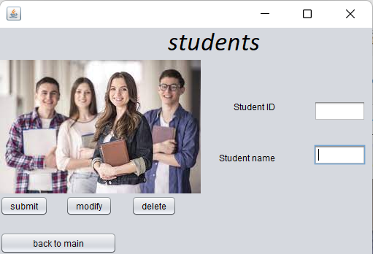

package student.distreess;

import java.sql.ResultSet;

import java.sql.Connection;

import java.sql.Driver;

import java.sql.DriverManager;

import java.sql.Statement;

public class student extends javax.swing.JFrame {

public student() {

initComponents();

}

private void initComponents() {

jLabel1 = new javax.swing.JLabel();

jLabel2 = new javax.swing.JLabel();

jTextField1 = new javax.swing.JTextField();

jTextField2 = new javax.swing.JTextField();

jButton1 = new javax.swing.JButton();

jLabel4 = new javax.swing.JLabel();

jButton2 = new javax.swing.JButton();

jButton3 = new javax.swing.JButton();

jButton4 = new javax.swing.JButton();

jLabel5 = new javax.swing.JLabel();

setDefaultCloseOperation(javax.swing.WindowConstants.EXIT_ON_CLOSE);

setBackground(new java.awt.Color(0, 0, 0));

getContentPane().setLayout(new org.netbeans.lib.awtextra.AbsoluteLayout());

jLabel1.setText("Student ID");

getContentPane().add(jLabel1, new org.netbeans.lib.awtextra.AbsoluteConstraints(320, 100, -1, -1));

jLabel2.setText("Student name");

getContentPane().add(jLabel2, new org.netbeans.lib.awtextra.AbsoluteConstraints(300, 170, -1, -1));

jTextField1.setText("jTextField1");

jTextField1.addActionListener(new java.awt.event.ActionListener() {

public void actionPerformed(java.awt.event.ActionEvent evt) {

jTextField1ActionPerformed(evt);

}

});

getContentPane().add(jTextField1, new org.netbeans.lib.awtextra.AbsoluteConstraints(430, 100, -1, -1));

jTextField2.setText("jTextField2");

getContentPane().add(jTextField2, new org.netbeans.lib.awtextra.AbsoluteConstraints(430, 160, -1, -1));

jButton1.setText("submit");

jButton1.addActionListener(new java.awt.event.ActionListener() {

public void actionPerformed(java.awt.event.ActionEvent evt) {

jButton1ActionPerformed(evt);

}

});

getContentPane().add(jButton1, new org.netbeans.lib.awtextra.AbsoluteConstraints(0, 230, -1, -1));

jLabel4.setFont(new java.awt.Font("Calibri", 2, 36)); // NOI18N

jLabel4.setText("students");

getContentPane().add(jLabel4, new org.netbeans.lib.awtextra.AbsoluteConstraints(230, 0, -1, -1));

jButton2.setText("back to main");

jButton2.addActionListener(new java.awt.event.ActionListener() {

public void actionPerformed(java.awt.event.ActionEvent evt) {

jButton2ActionPerformed(evt);

}

});

getContentPane().add(jButton2, new org.netbeans.lib.awtextra.AbsoluteConstraints(0, 280, 160, 30));

jButton3.setText("delete");

jButton3.addActionListener(new java.awt.event.ActionListener() {

public void actionPerformed(java.awt.event.ActionEvent evt) {

jButton3ActionPerformed(evt);

}

});

getContentPane().add(jButton3, new org.netbeans.lib.awtextra.AbsoluteConstraints(200, 230, -1, -1));

jButton4.setText("modify");

jButton4.addActionListener(new java.awt.event.ActionListener() {

public void actionPerformed(java.awt.event.ActionEvent evt) {

jButton4ActionPerformed(evt);

}

});

getContentPane().add(jButton4, new org.netbeans.lib.awtextra.AbsoluteConstraints(100, 230, -1, -1));

jLabel5.setBackground(new java.awt.Color(153, 153, 255));

jLabel5.setIcon(new javax.swing.ImageIcon("C:\\Users\\Gouri Manasa\\Desktop\\DM pdfs\\d2.jpg"));

getContentPane().add(jLabel5, new org.netbeans.lib.awtextra.AbsoluteConstraints(0, -50, 510, 370));

pack();

}

private void jButton1ActionPerformed(java.awt.event.ActionEvent evt) {

Connection con =null;

try

{

Driver myDriver = new oracle.jdbc.driver.OracleDriver();

DriverManager.registerDriver( myDriver );

con = DriverManager.getConnection("jdbc:oracle:thin:@localhost:1521:XE", "manasa", "vasavi");

Statement stmt = con.createStatement();

String query= "INSERT INTO students VALUES(" + "'" +jTextField1.getText() +"',"+ "'"+jTextField2.getText() +"')";

int i = stmt.executeUpdate(query);

System .out.println("Inserted ....");

stmt.close();

con.close();

}catch(Exception e){

System.out.println(e);

}

}

private void jButton2ActionPerformed(java.awt.event.ActionEvent evt) {

this.hide();

main m=new main();

m.show();

dispose();

}

private void jButton3ActionPerformed(java.awt.event.ActionEvent evt) {

try

{

DriverManager.registerDriver(new oracle.jdbc.driver.OracleDriver());

Connection con = DriverManager.getConnection("jdbc:oracle:thin:@localhost:1521:XE", "manasa", "vasavi");

Statement statement = con.createStatement();

String query= "DELETE from students where student_id='"+jTextField1.getText()+"'";

ResultSet rs = statement.executeQuery(query);

System .out.println("deleted");

rs.close();

statement.close();

con.close();

}

catch(Exception e)

{

System.out.println(e);

}

}

private void jTextField1ActionPerformed(java.awt.event.ActionEvent evt) {

}

private void jButton4ActionPerformed(java.awt.event.ActionEvent evt) {

try

{

DriverManager.registerDriver(new oracle.jdbc.driver.OracleDriver());

Connection con = DriverManager.getConnection("jdbc:oracle:thin:@localhost:1521:XE" ,"manasa","vasavi");

Statement statement = con.createStatement();

String query="update students set student_name ='"+jTextField2.getText()+"' where student_id= '"+jTextField1.getText()+"'";

ResultSet rs = statement.executeQuery(query);

rs.close();

statement.close();

con.close();

}

catch(Exception e)

{

System.out.println(e);

}

}

public static void main(String args[]) {

try {

for (javax.swing.UIManager.LookAndFeelInfo info : javax.swing.UIManager.getInstalledLookAndFeels()) {

if ("Nimbus".equals(info.getName())) {

javax.swing.UIManager.setLookAndFeel(info.getClassName());

break;

}

}

} catch (ClassNotFoundException ex) {

java.util.logging.Logger.getLogger(student.class.getName()).log(java.util.logging.Level.SEVERE, null, ex);

} catch (InstantiationException ex) {

java.util.logging.Logger.getLogger(student.class.getName()).log(java.util.logging.Level.SEVERE, null, ex);

} catch (IllegalAccessException ex) {

java.util.logging.Logger.getLogger(student.class.getName()).log(java.util.logging.Level.SEVERE, null, ex);

} catch (javax.swing.UnsupportedLookAndFeelException ex) {

java.util.logging.Logger.getLogger(student.class.getName()).log(java.util.logging.Level.SEVERE, null, ex);

}

java.awt.EventQueue.invokeLater(new Runnable() {

public void run() {

new student().setVisible(true);

}

});

}

private javax.swing.JButton jButton1;

private javax.swing.JButton jButton2;

private javax.swing.JButton jButton3;

private javax.swing.JButton jButton4;

private javax.swing.JLabel jLabel1;

private javax.swing.JLabel jLabel2;

private javax.swing.JLabel jLabel4;

private javax.swing.JLabel jLabel5;

private javax.swing.JTextField jTextField1;

private javax.swing.JTextField jTextField2;

}

**counsellor**

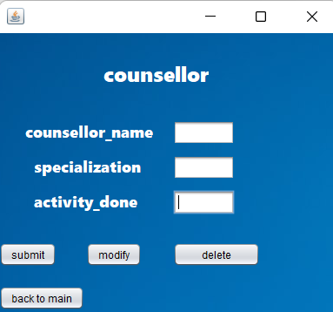

package student.distreess;

import java.sql.Connection;

import java.sql.Driver;

import java.sql.DriverManager;

import java.sql.ResultSet;

import java.sql.Statement;

public class counsellor extends javax.swing.JFrame {

public counsellor() {

initComponents();

}

private void initComponents() {

jLabel2 = new javax.swing.JLabel();

jButton2 = new javax.swing.JButton();

jLabel1 = new javax.swing.JLabel();

jLabel3 = new javax.swing.JLabel();

jLabel4 = new javax.swing.JLabel();

jTextField1 = new javax.swing.JTextField();

jTextField2 = new javax.swing.JTextField();

jTextField3 = new javax.swing.JTextField();

jButton1 = new javax.swing.JButton();

jButton3 = new javax.swing.JButton();

jButton4 = new javax.swing.JButton();

jLabel5 = new javax.swing.JLabel();

jButton5 = new javax.swing.JButton();

jLabel6 = new javax.swing.JLabel();

jLabel2.setText("jLabel2");

jButton2.setText("jButton2");

setDefaultCloseOperation(javax.swing.WindowConstants.EXIT_ON_CLOSE);

getContentPane().setLayout(new org.netbeans.lib.awtextra.AbsoluteLayout());

jLabel1.setBackground(new java.awt.Color(0, 0, 0));

jLabel1.setFont(new java.awt.Font("Segoe UI Black", 0, 18)); // NOI18N

jLabel1.setForeground(new java.awt.Color(255, 255, 255));

jLabel1.setText("counsellor_name");

getContentPane().add(jLabel1, new org.netbeans.lib.awtextra.AbsoluteConstraints(30, 100, -1, -1));

jLabel3.setFont(new java.awt.Font("Segoe UI Black", 0, 18)); // NOI18N

jLabel3.setForeground(new java.awt.Color(255, 255, 255));

jLabel3.setText("specialization");

getContentPane().add(jLabel3, new org.netbeans.lib.awtextra.AbsoluteConstraints(40, 140, 130, -1));

jLabel4.setFont(new java.awt.Font("Segoe UI Black", 0, 18));

jLabel4.setForeground(new java.awt.Color(255, 255, 255));

jLabel4.setText("activity_done");

getContentPane().add(jLabel4, new org.netbeans.lib.awtextra.AbsoluteConstraints(40, 180, 130, -1));

jTextField1.setText("jTextField1");

getContentPane().add(jTextField1, new org.netbeans.lib.awtextra.AbsoluteConstraints(200, 100, -1, -1));

jTextField2.setText("jTextField2");

getContentPane().add(jTextField2, new org.netbeans.lib.awtextra.AbsoluteConstraints(200, 140, -1, -1));

jTextField3.setText("jTextField3");

getContentPane().add(jTextField3, new org.netbeans.lib.awtextra.AbsoluteConstraints(200, 180, -1, -1));

jButton1.setText("back to main");

jButton1.addActionListener(new java.awt.event.ActionListener() {

public void actionPerformed(java.awt.event.ActionEvent evt) {

jButton1ActionPerformed(evt);

}

});

getContentPane().add(jButton1, new org.netbeans.lib.awtextra.AbsoluteConstraints(0, 290, -1, -1));

jButton3.setText("delete");

jButton3.addActionListener(new java.awt.event.ActionListener() {

public void actionPerformed(java.awt.event.ActionEvent evt) {

jButton3ActionPerformed(evt);

}

});

getContentPane().add(jButton3, new org.netbeans.lib.awtextra.AbsoluteConstraints(200, 240, 100, -1))

jButton4.setText("submit");

jButton4.addActionListener(new java.awt.event.ActionListener() {

public void actionPerformed(java.awt.event.ActionEvent evt) {

jButton4ActionPerformed(evt);

}

});

getContentPane().add(jButton4, new org.netbeans.lib.awtextra.AbsoluteConstraints(0, 240, -1, -1));

jLabel5.setFont(new java.awt.Font("Segoe UI Black", 0, 24));

jLabel5.setForeground(new java.awt.Color(255, 255, 255));

jLabel5.setText("counsellor");

getContentPane().add(jLabel5, new org.netbeans.lib.awtextra.AbsoluteConstraints(120, 30, -1, -1));

jButton5.setText("modify");

jButton5.addActionListener(new java.awt.event.ActionListener() {

public void actionPerformed(java.awt.event.ActionEvent evt) {

jButton5ActionPerformed(evt);

}

});

getContentPane().add(jButton5, new org.netbeans.lib.awtextra.AbsoluteConstraints(100, 240, -1, -1));

jLabel6.setIcon(new javax.swing.ImageIcon("C:\\Users\\Gouri Manasa\\Desktop\\DM pdfs\\rr.jpg"));

getContentPane().add(jLabel6, new org.netbeans.lib.awtextra.AbsoluteConstraints(0, -20, 390, 350));

pack();

}

private void jButton1ActionPerformed(java.awt.event.ActionEvent evt) {

this.hide();

main m=new main();

m.show();

dispose();

}

private void jButton4ActionPerformed(java.awt.event.ActionEvent evt) {

Connection con =null;

try

{

Driver myDriver = new oracle.jdbc.driver.OracleDriver();

DriverManager.registerDriver( myDriver );

con = DriverManager.getConnection("jdbc:oracle:thin:@localhost:1521:XE", "manasa", "vasavi");

Statement stmt = con.createStatement();

String query= "INSERT INTO counsellor VALUES(" + "'" +jTextField1.getText() + "',"+ "'" +jTextField2.getText() +"',"+"'"+ jTextField3.getText()+"')";

int i = stmt.executeUpdate(query);

System .out.println("Inserted ....");

stmt.close();

con.close();

}catch(Exception e){

System.out.println(e);

}

}

private void jButton3ActionPerformed(java.awt.event.ActionEvent evt) {

Connection con =null;

try

{

Driver myDriver = new oracle.jdbc.driver.OracleDriver();

DriverManager.registerDriver( myDriver );

con = DriverManager.getConnection("jdbc:oracle:thin:@localhost:1521:XE", "manasa", "vasavi");

Statement stmt = con.createStatement();

String query= "DELETE from counsellor where coun_name='"+jTextField1.getText()+"'";

int i = stmt.executeUpdate(query);

System .out.println("deleted ....");

stmt.close();

con.close();

}catch(Exception e){

System.out.println(e);

}

}

private void jButton5ActionPerformed(java.awt.event.ActionEvent evt) {

try

{

DriverManager.registerDriver(new oracle.jdbc.driver.OracleDriver());

Connection con = DriverManager.getConnection("jdbc:oracle:thin:@localhost:1521:XE" ,"manasa","vasavi");

Statement statement = con.createStatement();

String query="update counsellor set activity_done ='"+jTextField3.getText()+"',specialization ='"+jTextField2.getText()+"' where coun_name= '"+jTextField1.getText()+"'";

ResultSet rs = statement.executeQuery(query);

System.out.println("updated......");

rs.close();

statement.close();

con.close();

}

catch(Exception e)

{

System.out.println(e);

}

}

try {

for (javax.swing.UIManager.LookAndFeelInfo info : javax.swing.UIManager.getInstalledLookAndFeels()) {

if ("Nimbus".equals(info.getName())) {

javax.swing.UIManager.setLookAndFeel(info.getClassName());

break;

}

}

} catch (ClassNotFoundException ex) {

java.util.logging.Logger.getLogger(counsellor.class.getName()).log(java.util.logging.Level.SEVERE, null, ex);

} catch (InstantiationException ex) {

java.util.logging.Logger.getLogger(counsellor.class.getName()).log(java.util.logging.Level.SEVERE, null, ex);

} catch (IllegalAccessException ex) {

java.util.logging.Logger.getLogger(counsellor.class.getName()).log(java.util.logging.Level.SEVERE, null, ex);

} catch (javax.swing.UnsupportedLookAndFeelException ex) {

java.util.logging.Logger.getLogger(counsellor.class.getName()).log(java.util.logging.Level.SEVERE, null, ex);

}

//</editor-fold>

/* Create and display the form */

java.awt.EventQueue.invokeLater(new Runnable() {

public void run() {

new counsellor().setVisible(true);

}

});

}

private javax.swing.JButton jButton1;

private javax.swing.JButton jButton2;

private javax.swing.JButton jButton3;

private javax.swing.JButton jButton4;

private javax.swing.JButton jButton5;

private javax.swing.JLabel jLabel1;

private javax.swing.JLabel jLabel2;

private javax.swing.JLabel jLabel3;

private javax.swing.JLabel jLabel4;

private javax.swing.JLabel jLabel5;

private javax.swing.JLabel jLabel6;

private javax.swing.JTextField jTextField1;

private javax.swing.JTextField jTextField2;

private javax.swing.JTextField jTextField3;

}

**Stress categories**

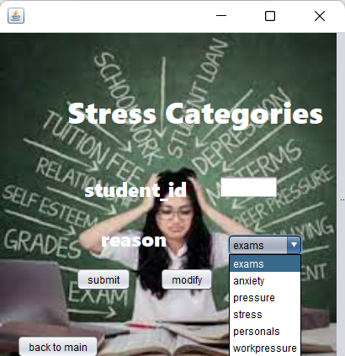

package student.distreess;

import java.sql.Connection;

import java.sql.Driver;

import java.sql.DriverManager;

import java.sql.ResultSet;

import java.sql.Statement;

public class stress_categories extends javax.swing.JFrame {

public stress_categories() {

initComponents();

}

private void initComponents() {

jButton4 = new javax.swing.JButton();

jButton5 = new javax.swing.JButton();

jLabel1 = new javax.swing.JLabel();

jTextField1 = new javax.swing.JTextField();

jLabel2 = new javax.swing.JLabel();

jComboBox1 = new javax.swing.JComboBox<>();

jLabel3 = new javax.swing.JLabel();

jButton1 = new javax.swing.JButton();

jButton2 = new javax.swing.JButton();

jButton3 = new javax.swing.JButton();

jButton6 = new javax.swing.JButton();

jLabel4 = new javax.swing.JLabel();

jButton4.setText("jButton4");

jButton5.setText("jButton5");

setDefaultCloseOperation(javax.swing.WindowConstants.EXIT_ON_CLOSE);

getContentPane().setLayout(new org.netbeans.lib.awtextra.AbsoluteLayout());

jLabel1.setBackground(new java.awt.Color(255, 153, 255));

jLabel1.setFont(new java.awt.Font("Segoe UI Black", 0, 24)); // NOI18N

jLabel1.setForeground(new java.awt.Color(255, 255, 255));

jLabel1.setText("student_id");

getContentPane().add(jLabel1, new org.netbeans.lib.awtextra.AbsoluteConstraints(100, 170,140,1));

jTextField1.setText("jTextField1");

jTextField1.addActionListener(new java.awt.event.ActionListener() {

public void actionPerformed(java.awt.event.ActionEvent evt) {

jTextField1ActionPerformed(evt);

}

});

getContentPane().add(jTextField1, new org.netbeans.lib.awtextra.AbsoluteConstraints(260, 170, -1, -1));

jLabel2.setBackground(new java.awt.Color(51, 51, 51));

jLabel2.setFont(new java.awt.Font("Segoe UI Black", 0, 24)); // NOI18N

jLabel2.setForeground(new java.awt.Color(255, 255, 255));

jLabel2.setText("reason");

getContentPane().add(jLabel2, new org.netbeans.lib.awtextra.AbsoluteConstraints(120, 230, 100, 30));

jComboBox1.setModel(new javax.swing.DefaultComboBoxModel<>(new String[] { "exams", "anxiety", "pressure", "stress", "personals", "workpressure" }));

jComboBox1.addActionListener(new java.awt.event.ActionListener() {

public void actionPerformed(java.awt.event.ActionEvent evt) {

jComboBox1ActionPerformed(evt);

}

});

getContentPane().add(jComboBox1, new org.netbeans.lib.awtextra.AbsoluteConstraints(270, 240, 90, -1));

jLabel3.setFont(new java.awt.Font("Segoe UI Black", 0, 36)); // NOI18N

jLabel3.setForeground(new java.awt.Color(255, 255, 255));

jLabel3.setText("Stress Categories");

getContentPane().add(jLabel3, new org.netbeans.lib.awtextra.AbsoluteConstraints(80, 70, -1, -1));

jButton1.setText("submit");

jButton1.addActionListener(new java.awt.event.ActionListener() {

public void actionPerformed(java.awt.event.ActionEvent evt) {

jButton1ActionPerformed(evt);

}

});

getContentPane().add(jButton1, new org.netbeans.lib.awtextra.AbsoluteConstraints(90, 280, -1, -1));

jButton2.setText("modify");

jButton2.addActionListener(new java.awt.event.ActionListener() {

public void actionPerformed(java.awt.event.ActionEvent evt) {

jButton2ActionPerformed(evt);

}

});

getContentPane().add(jButton2, new org.netbeans.lib.awtextra.AbsoluteConstraints(190, 280, -1, -1));

jButton3.setText("delete");

jButton3.addActionListener(new java.awt.event.ActionListener() {

public void actionPerformed(java.awt.event.ActionEvent evt) {

jButton3ActionPerformed(evt);

}

});

getContentPane().add(jButton3, new org.netbeans.lib.awtextra.AbsoluteConstraints(290, 280, -1, -1));

jButton6.setText("back to main");

getContentPane().add(jButton6, new org.netbeans.lib.awtextra.AbsoluteConstraints(20, 360, -1, -1));

jLabel4.setIcon(new javax.swing.ImageIcon("C:\\Users\\Gouri Manasa\\Desktop\\DM pdfs\\d1 (4).jpg"));

jLabel4.setText("jLabel4");

getContentPane().add(jLabel4, new org.netbeans.lib.awtextra.AbsoluteConstraints(0, -50, 410, 490));

pack();

}

private void jComboBox1ActionPerformed(java.awt.event.ActionEvent evt) {

}

private void jTextField1ActionPerformed(java.awt.event.ActionEvent evt) {

}

private void jButton2ActionPerformed(java.awt.event.ActionEvent evt) {

try

{

DriverManager.registerDriver(new oracle.jdbc.driver.OracleDriver());

Connection con = DriverManager.getConnection("jdbc:oracle:thin:@localhost:1521:XE" ,"manasa","vasavi");

Statement statement = con.createStatement();

String query="update stress_categories set student_id ='"+jTextField1.getText()+"' where reason= '"+jComboBox1.getSelectedItem()+"'";

ResultSet rs = statement.executeQuery(query);

System.out.println("updated......");

rs.close();

statement.close();

con.close();

}

catch(Exception e)

{

System.out.println(e);

}

}

private void jButton1ActionPerformed(java.awt.event.ActionEvent evt) {

Connection con =null;

try

{

Driver myDriver = new oracle.jdbc.driver.OracleDriver();

DriverManager.registerDriver( myDriver );

con = DriverManager.getConnection("jdbc:oracle:thin:@localhost:1521:XE", "manasa", "vasavi");

Statement stmt = con.createStatement();

String query= "INSERT INTO stress_categories VALUES(" + "'" +jTextField1.getText() +"',"+ "'"+jComboBox1.getSelectedItem() +"')";

int i = stmt.executeUpdate(query);

System .out.println("Inserted ....");

stmt.close();

con.close();

}catch(Exception e){

System.out.println(e);

}

}

private void jButton3ActionPerformed(java.awt.event.ActionEvent evt) {

Connection con =null;

try

{

Driver myDriver = new oracle.jdbc.driver.OracleDriver();

DriverManager.registerDriver( myDriver );

con = DriverManager.getConnection("jdbc:oracle:thin:@localhost:1521:XE", "manasa", "vasavi");

Statement stmt = con.createStatement();

String query= "DELETE from stress_categories where student_id='"+jTextField1.getText()+"'";

int i = stmt.executeUpdate(query);

System .out.println("deleted ....");

stmt.close();

con.close();

}catch(Exception e){

System.out.println(e);

}

}

public static void main(String args[]) {

try {

for (javax.swing.UIManager.LookAndFeelInfo info : javax.swing.UIManager.getInstalledLookAndFeels()) {

if ("Nimbus".equals(info.getName())) {

javax.swing.UIManager.setLookAndFeel(info.getClassName());

break;

}

}

} catch (ClassNotFoundException ex) {

java.util.logging.Logger.getLogger(stress_categories.class.getName()).log(java.util.logging.Level.SEVERE, null, ex);

} catch (InstantiationException ex) {

java.util.logging.Logger.getLogger(stress_categories.class.getName()).log(java.util.logging.Level.SEVERE, null, ex);

} catch (IllegalAccessException ex) {

java.util.logging.Logger.getLogger(stress_categories.class.getName()).log(java.util.logging.Level.SEVERE, null, ex);

} catch (javax.swing.UnsupportedLookAndFeelException ex) {

java.util.logging.Logger.getLogger(stress_categories.class.getName()).log(java.util.logging.Level.SEVERE, null, ex);

}

java.awt.EventQueue.invokeLater(new Runnable() {

public void run() {

new stress_categories().setVisible(true);

}

});

}

private javax.swing.JButton jButton1;

private javax.swing.JButton jButton2;

private javax.swing.JButton jButton3;

private javax.swing.JButton jButton4;

private javax.swing.JButton jButton5;

private javax.swing.JButton jButton6;

private javax.swing.JComboBox<String> jComboBox1;

private javax.swing.JLabel jLabel1;

private javax.swing.JLabel jLabel2;

private javax.swing.JLabel jLabel3;

private javax.swing.JLabel jLabel4;

private javax.swing.JTextField jTextField1;

}

**Academic_activities**

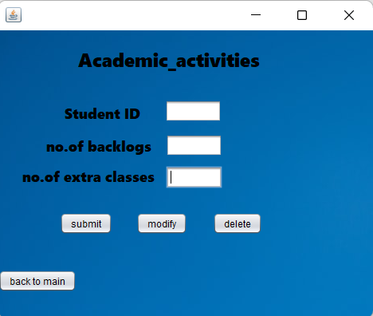

package student.distreess;

import java.sql.Connection;

import java.sql.Driver;

import java.sql.DriverManager;

import java.sql.ResultSet;

import java.sql.Statement;

public class Academic_activities extends javax.swing.JFrame {

public Academic_activities() {

initComponents();

}

private void initComponents() {

jLabel1 = new javax.swing.JLabel();

jLabel2 = new javax.swing.JLabel();

jTextField1 = new javax.swing.JTextField();

jLabel3 = new javax.swing.JLabel();

jTextField2 = new javax.swing.JTextField();

jLabel4 = new javax.swing.JLabel();

jTextField3 = new javax.swing.JTextField();

jButton1 = new javax.swing.JButton();

jButton2 = new javax.swing.JButton();

jButton3 = new javax.swing.JButton();

jButton4 = new javax.swing.JButton();

jLabel5 = new javax.swing.JLabel();

setDefaultCloseOperation(javax.swing.WindowConstants.EXIT_ON_CLOSE);

getContentPane().setLayout(new org.netbeans.lib.awtextra.AbsoluteLayout());

jLabel1.setFont(new java.awt.Font("Segoe UI Black", 0, 24)); // NOI18N

jLabel1.setText("Academic_activities");

getContentPane().add(jLabel1, new org.netbeans.lib.awtextra.AbsoluteConstraints(100, 20, -1, -1));

jLabel2.setFont(new java.awt.Font("Segoe UI Black", 0, 18)); // NOI18N

jLabel2.setText("Student ID");

getContentPane().add(jLabel2, new org.netbeans.lib.awtextra.AbsoluteConstraints(83, 91, 120, -1));

jTextField1.setText("jTextField1");

getContentPane().add(jTextField1, new org.netbeans.lib.awtextra.AbsoluteConstraints(209, 87, -1, -1));

jLabel3.setFont(new java.awt.Font("Segoe UI Black", 0, 18)); // NOI18N

jLabel3.setText("no.of backlogs ");

getContentPane().add(jLabel3, new org.netbeans.lib.awtextra.AbsoluteConstraints(60, 130, 140, 30));

jTextField2.setText("jTextField2");

getContentPane().add(jTextField2, new org.netbeans.lib.awtextra.AbsoluteConstraints(210, 130, -1, -1));

jLabel4.setFont(new java.awt.Font("Segoe UI Black", 0, 18)); // NOI18N

jLabel4.setText("no.of extra classes");

getContentPane().add(jLabel4, new org.netbeans.lib.awtextra.AbsoluteConstraints(30, 170, -1, -1));

jTextField3.setText("jTextField3");

getContentPane().add(jTextField3, new org.netbeans.lib.awtextra.AbsoluteConstraints(210, 170, -1, -1));

jButton1.setText("submit");

jButton1.addActionListener(new java.awt.event.ActionListener() {

public void actionPerformed(java.awt.event.ActionEvent evt) {

jButton1ActionPerformed(evt);

}

});

getContentPane().add(jButton1, new org.netbeans.lib.awtextra.AbsoluteConstraints(77, 228, -1, -1));

jButton2.setText("back to main");

jButton2.addActionListener(new java.awt.event.ActionListener() {

public void actionPerformed(java.awt.event.ActionEvent evt) {

jButton2ActionPerformed(evt);

}

});

getContentPane().add(jButton2, new org.netbeans.lib.awtextra.AbsoluteConstraints(0, 300, -1, -1));

jButton3.setText("delete");

jButton3.addActionListener(new java.awt.event.ActionListener() {

public void actionPerformed(java.awt.event.ActionEvent evt) {

jButton3ActionPerformed(evt);

}

});

getContentPane().add(jButton3, new org.netbeans.lib.awtextra.AbsoluteConstraints(269, 228, -1, -1));

jButton4.setText("modify");

jButton4.addActionListener(new java.awt.event.ActionListener() {

public void actionPerformed(java.awt.event.ActionEvent evt) {

jButton4ActionPerformed(evt);

}

});

getContentPane().add(jButton4, new org.netbeans.lib.awtextra.AbsoluteConstraints(173, 228, -1, -1));

jLabel5.setIcon(new javax.swing.ImageIcon("C:\\Users\\Gouri Manasa\\Desktop\\DM pdfs\\rr.jpg"));

getContentPane().add(jLabel5, new org.netbeans.lib.awtextra.AbsoluteConstraints(-10, 0, 480, 360));

pack();

}

private void jButton1ActionPerformed(java.awt.event.ActionEvent evt) {

Connection con =null;

try

{

Driver myDriver = new oracle.jdbc.driver.OracleDriver();

DriverManager.registerDriver( myDriver );

con = DriverManager.getConnection("jdbc:oracle:thin:@localhost:1521:XE", "manasa", "vasavi");

Statement stmt = con.createStatement();

String query= "INSERT INTO acadamic_activities VALUES(" + "'" +jTextField1.getText() + "'," +jTextField2.getText() +","+jTextField3.getText()+")";

int i = stmt.executeUpdate(query);

System .out.println("Inserted ....");

stmt.close();

con.close();

}catch(Exception e){

System.out.println(e);

}

}

private void jButton2ActionPerformed(java.awt.event.ActionEvent evt) {

this.hide();

main m=new main();

m.show();

dispose();

}

private void jButton3ActionPerformed(java.awt.event.ActionEvent evt) {

Connection con =null;

try

{

Driver myDriver = new oracle.jdbc.driver.OracleDriver();

DriverManager.registerDriver( myDriver );

con = DriverManager.getConnection("jdbc:oracle:thin:@localhost:1521:XE", "manasa", "vasavi");

Statement stmt = con.createStatement();

String query= "DELETE from acadamic_activities where student_id='"+jTextField1.getText()+"'";

int i = stmt.executeUpdate(query);

System .out.println("deleted ....");

stmt.close();

con.close();

}catch(Exception e){

System.out.println(e);

}

}

private void jButton4ActionPerformed(java.awt.event.ActionEvent evt) {

try

{

DriverManager.registerDriver(new oracle.jdbc.driver.OracleDriver());

Connection con = DriverManager.getConnection("jdbc:oracle:thin:@localhost:1521:XE" ,"manasa","vasavi");

Statement statement = con.createStatement();

String query="update acadamic_activities set no_of_backlogs ='"+jTextField2.getText()+"', no_of_extraclasses_perweek='"+jTextField3.getText()+"' where student_id= '"+jTextField1.getText()+"'";

ResultSet rs = statement.executeQuery(query);

System.out.println("updated......");

rs.close();

statement.close();

con.close();

} catch(Exception e)

{

System.out.println(e);

}

}

public static void main(String args[]) {

try {

for (javax.swing.UIManager.LookAndFeelInfo info : javax.swing.UIManager.getInstalledLookAndFeels()) {

if ("Nimbus".equals(info.getName())) {

javax.swing.UIManager.setLookAndFeel(info.getClassName());

break;

}

}

} catch (ClassNotFoundException ex) {

java.util.logging.Logger.getLogger(Academic_activities.class.getName()).log(java.util.logging.Level.SEVERE, null, ex);

} catch (InstantiationException ex) {

java.util.logging.Logger.getLogger(Academic_activities.class.getName()).log(java.util.logging.Level.SEVERE, null, ex);

} catch (IllegalAccessException ex) {

java.util.logging.Logger.getLogger(Academic_activities.class.getName()).log(java.util.logging.Level.SEVERE, null, ex);

} catch (javax.swing.UnsupportedLookAndFeelException ex) {

java.util.logging.Logger.getLogger(Academic_activities.class.getName()).log(java.util.logging.Level.SEVERE, null, ex);

}

java.awt.EventQueue.invokeLater(new Runnable() {

public void run() {

new Academic_activities().setVisible(true);

}

});

}

private javax.swing.JButton jButton1;

private javax.swing.JButton jButton2;

private javax.swing.JButton jButton3;

private javax.swing.JButton jButton4;

private javax.swing.JLabel jLabel1;

private javax.swing.JLabel jLabel2;

private javax.swing.JLabel jLabel3;

private javax.swing.JLabel jLabel4;

private javax.swing.JLabel jLabel5;

private javax.swing.JTextField jTextField1;

private javax.swing.JTextField jTextField2;

private javax.swing.JTextField jTextField3;

}

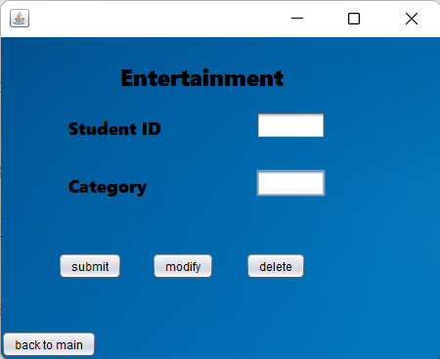

import java.sql.Connection;

import java.sql.Driver;

import java.sql.DriverManager;

import java.sql.ResultSet;

import java.sql.Statement;

public class Entertainment extends javax.swing.JFrame {

public Entertainment() {

initComponents();

}

private void initComponents() {

jLabel1 = new javax.swing.JLabel();

jLabel2 = new javax.swing.JLabel();

jTextField1 = new javax.swing.JTextField();

jTextField2 = new javax.swing.JTextField();

jLabel3 = new javax.swing.JLabel();

jButton1 = new javax.swing.JButton();

jButton2 = new javax.swing.JButton();

jButton3 = new javax.swing.JButton();

jButton4 = new javax.swing.JButton();

jLabel4 = new javax.swing.JLabel();

setDefaultCloseOperation(javax.swing.WindowConstants.EXIT_ON_CLOSE);

getContentPane().setLayout(new org.netbeans.lib.awtextra.AbsoluteLayout());

jLabel1.setFont(new java.awt.Font("Segoe UI Black", 0, 18)); // NOI18N

jLabel1.setText("Student ID");

getContentPane().add(jLabel1, new org.netbeans.lib.awtextra.AbsoluteConstraints(69, 80, -1, -1));

jLabel2.setFont(new java.awt.Font("Segoe UI Black", 0, 18)); // NOI18N

jLabel2.setText("Category");

getContentPane().add(jLabel2, new org.netbeans.lib.awtextra.AbsoluteConstraints(69, 139, -1, -1));

jTextField1.setText("jTextField1");

getContentPane().add(jTextField1, new org.netbeans.lib.awtextra.AbsoluteConstraints(261, 76, -1, -1));

jTextField2.setText("jTextField2");

getContentPane().add(jTextField2, new org.netbeans.lib.awtextra.AbsoluteConstraints(261, 135, -1, -1));

jLabel3.setFont(new java.awt.Font("Segoe UI Black", 0, 24)); // NOI18N

jLabel3.setText("Entertainment");

getContentPane().add(jLabel3, new org.netbeans.lib.awtextra.AbsoluteConstraints(122, 24, -1, -1));

jButton1.setText("submit");

jButton1.addActionListener(new java.awt.event.ActionListener() {

public void actionPerformed(java.awt.event.ActionEvent evt) {

jButton1ActionPerformed(evt);

}

});

getContentPane().add(jButton1, new org.netbeans.lib.awtextra.AbsoluteConstraints(58, 220, -1, -1));

jButton2.setText("back to main");

getContentPane().add(jButton2, new org.netbeans.lib.awtextra.AbsoluteConstraints(0, 300, -1, -1));

jButton3.setText("delete");

jButton3.addActionListener(new java.awt.event.ActionListener() {

public void actionPerformed(java.awt.event.ActionEvent evt) {

jButton3ActionPerformed(evt);

}

});

getContentPane().add(jButton3, new org.netbeans.lib.awtextra.AbsoluteConstraints(250, 220, -1, -1));

jButton4.setText("modify");

jButton4.addActionListener(new java.awt.event.ActionListener() {

public void actionPerformed(java.awt.event.ActionEvent evt) {

jButton4ActionPerformed(evt);

}

});

getContentPane().add(jButton4, new org.netbeans.lib.awtextra.AbsoluteConstraints(154, 220, -1, -1));

jLabel4.setFont(new java.awt.Font("Segoe UI Black", 0, 18)); // NOI18N

jLabel4.setIcon(new javax.swing.ImageIcon("C:\\Users\\Gouri Manasa\\Desktop\\DM pdfs\\rr.jpg"));

getContentPane().add(jLabel4, new org.netbeans.lib.awtextra.AbsoluteConstraints(0, 0, 450, 330));

pack();

}

private void jButton1ActionPerformed(java.awt.event.ActionEvent evt) {

Connection con =null;

try

{

Driver myDriver = new oracle.jdbc.driver.OracleDriver();

DriverManager.registerDriver( myDriver );

con = DriverManager.getConnection("jdbc:oracle:thin:@localhost:1521:XE", "manasa", "vasavi");

Statement stmt = con.createStatement();

String query= "INSERT INTO entertainment VALUES(" + "'" +jTextField1.getText() +"',"+ "'"+jTextField2.getText() +"')";

int i = stmt.executeUpdate(query);

System .out.println("Inserted ....");

stmt.close();

con.close();

}catch(Exception e){

System.out.println(e);

}

}

private void jButton3ActionPerformed(java.awt.event.ActionEvent evt) {

Connection con =null;

try

{

Driver myDriver = new oracle.jdbc.driver.OracleDriver();

DriverManager.registerDriver( myDriver );

con = DriverManager.getConnection("jdbc:oracle:thin:@localhost:1521:XE", "manasa", "vasavi");

Statement stmt = con.createStatement();

String query= "DELETE from entertainment where student_id='"+jTextField1.getText()+"'";

int i = stmt.executeUpdate(query);

System .out.println("deleted ....");

stmt.close();

con.close();

}catch(Exception e){

System.out.println(e);

}

}

private void jButton4ActionPerformed(java.awt.event.ActionEvent evt) {

try

{

DriverManager.registerDriver(new oracle.jdbc.driver.OracleDriver());

Connection con = DriverManager.getConnection("jdbc:oracle:thin:@localhost:1521:XE" ,"manasa","vasavi");

Statement statement = con.createStatement();

String query="update entertainment set category ='"+jTextField2.getText()+"' where student_id= '"+jTextField1.getText()+"'";

ResultSet rs = statement.executeQuery(query);

rs.close();

statement.close();

con.close();

}

catch(Exception e){

System.out.println("updated.......");

}

}

public static void main(String args[]) {

try {

for (javax.swing.UIManager.LookAndFeelInfo info : javax.swing.UIManager.getInstalledLookAndFeels()) {

if ("Nimbus".equals(info.getName())) {

javax.swing.UIManager.setLookAndFeel(info.getClassName());

break;

}

}

} catch (ClassNotFoundException ex) {

java.util.logging.Logger.getLogger(Entertainment.class.getName()).log(java.util.logging.Level.SEVERE, null, ex);

} catch (InstantiationException ex) {

java.util.logging.Logger.getLogger(Entertainment.class.getName()).log(java.util.logging.Level.SEVERE, null, ex);

} catch (IllegalAccessException ex) {

java.util.logging.Logger.getLogger(Entertainment.class.getName()).log(java.util.logging.Level.SEVERE, null, ex);

} catch (javax.swing.UnsupportedLookAndFeelException ex) {

java.util.logging.Logger.getLogger(Entertainment.class.getName()).log(java.util.logging.Level.SEVERE, null, ex);

}

java.awt.EventQueue.invokeLater(new Runnable() {

public void run() {

new Entertainment().setVisible(true);

}

});

}

private javax.swing.JButton jButton1;

private javax.swing.JButton jButton2;

private javax.swing.JButton jButton3;

private javax.swing.JButton jButton4;

private javax.swing.JLabel jLabel1;

private javax.swing.JLabel jLabel2;

private javax.swing.JLabel jLabel3;

private javax.swing.JLabel jLabel4;

private javax.swing.JTextField jTextField1;

private javax.swing.JTextField jTextField2;

}

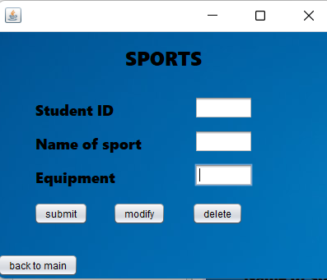

package student.distreess;

import java.sql.Connection;

import java.sql.Driver;

import java.sql.DriverManager;

import java.sql.ResultSet;

import java.sql.Statement;

public class Sports extends javax.swing.JFrame {

public Sports() {

initComponents();

}

private void initComponents() {

jTextField2 = new javax.swing.JTextField();

jLabel1 = new javax.swing.JLabel();

jLabel2 = new javax.swing.JLabel();

jLabel3 = new javax.swing.JLabel();

jLabel4 = new javax.swing.JLabel();

jTextField1 = new javax.swing.JTextField();

jTextField3 = new javax.swing.JTextField();

jTextField4 = new javax.swing.JTextField();

jButton1 = new javax.swing.JButton();

jButton2 = new javax.swing.JButton();

jButton3 = new javax.swing.JButton();

jButton4 = new javax.swing.JButton();

jLabel5 = new javax.swing.JLabel();

jTextField2.setText("jTextField2");

setDefaultCloseOperation(javax.swing.WindowConstants.EXIT_ON_CLOSE);

getContentPane().setLayout(new org.netbeans.lib.awtextra.AbsoluteLayout());

jLabel1.setFont(new java.awt.Font("Segoe UI Black", 0, 24));

jLabel1.setText("SPORTS");

getContentPane().add(jLabel1, new org.netbeans.lib.awtextra.AbsoluteConstraints(155, 16, -1, -1));

jLabel2.setFont(new java.awt.Font("Segoe UI Black", 0, 18)); // NOI18N

jLabel2.setText("Student ID");

getContentPane().add(jLabel2, new org.netbeans.lib.awtextra.AbsoluteConstraints(46, 83,+91, -1));

jLabel3.setFont(new java.awt.Font("Segoe UI Black", 0, 18)); // NOI18N

jLabel3.setText("Name of sport");

getContentPane().add(jLabel3, new org.netbeans.lib.awtextra.AbsoluteConstraints(46, 124, -1, -1));

jLabel4.setFont(new java.awt.Font("Segoe UI Black", 0, 18)); // NOI18N

jLabel4.setText("Equipment");

getContentPane().add(jLabel4, new org.netbeans.lib.awtextra.AbsoluteConstraints(46, 165, -1, -1));

jTextField1.setText("jTextField1");

getContentPane().add(jTextField1, new org.netbeans.lib.awtextra.AbsoluteConstraints(239, 79, -1, -1));

jTextField3.setText("jTextField3");

getContentPane().add(jTextField3, new org.netbeans.lib.awtextra.AbsoluteConstraints(239, 120, -1, -1));

jTextField4.setText("jTextField4");

getContentPane().add(jTextField4, new org.netbeans.lib.awtextra.AbsoluteConstraints(239, 161, -1, -1));

jButton1.setText("submit");

jButton1.addActionListener(new java.awt.event.ActionListener() {

public void actionPerformed(java.awt.event.ActionEvent evt) {

jButton1ActionPerformed(evt);

}

});

getContentPane().add(jButton1, new org.netbeans.lib.awtextra.AbsoluteConstraints(44, 208, -1, -1));

jButton2.setText("back to main");

jButton2.addActionListener(new java.awt.event.ActionListener() {

public void actionPerformed(java.awt.event.ActionEvent evt) {

jButton2ActionPerformed(evt);

}

});

getContentPane().add(jButton2, new org.netbeans.lib.awtextra.AbsoluteConstraints(0, 271, -1, -1));

jButton3.setText("delete");

jButton3.addActionListener(new java.awt.event.ActionListener() {

public void actionPerformed(java.awt.event.ActionEvent evt) {

jButton3ActionPerformed(evt);

}

});

getContentPane().add(jButton3, new org.netbeans.lib.awtextra.AbsoluteConstraints(236, 208, -1, -1));

jButton4.setText("modify");

jButton4.addActionListener(new java.awt.event.ActionListener() {

public void actionPerformed(java.awt.event.ActionEvent evt) {

jButton4ActionPerformed(evt);

}

});

getContentPane().add(jButton4, new org.netbeans.lib.awtextra.AbsoluteConstraints(140, 208, -1, -1));

jLabel5.setFont(new java.awt.Font("Segoe UI Black", 0, 18)); // NOI18N

jLabel5.setForeground(new java.awt.Color(255, 255, 255));

jLabel5.setIcon(new javax.swing.ImageIcon("C:\\Users\\Gouri Manasa\\Desktop\\DM pdfs\\rr.jpg")); // NOI18N

getContentPane().add(jLabel5, new org.netbeans.lib.awtextra.AbsoluteConstraints(-2, 1, 410, 300));

pack();

}// </editor-fold>

private void jButton1ActionPerformed(java.awt.event.ActionEvent evt) {

Connection con =null;

try

{

Driver myDriver = new oracle.jdbc.driver.OracleDriver();

DriverManager.registerDriver( myDriver );

con = DriverManager.getConnection("jdbc:oracle:thin:@localhost:1521:XE", "manasa", "vasavi");

Statement stmt = con.createStatement();

String query= "INSERT INTO sports VALUES(" + "'" +jTextField1.getText() + "',"+ "'" +jTextField3.getText() +"',"+"'"+ jTextField4.getText()+"')";

int i = stmt.executeUpdate(query);

System .out.println("Inserted ....");

stmt.close();

con.close();

}catch(Exception e){

System.out.println(e);

}

}

private void jButton2ActionPerformed(java.awt.event.ActionEvent evt) {

this.hide();

main m=new main();

m.show();

dispose();

}

private void jButton3ActionPerformed(java.awt.event.ActionEvent evt) {

Connection con =null;

try

{

Driver myDriver = new oracle.jdbc.driver.OracleDriver();

DriverManager.registerDriver( myDriver );

con = DriverManager.getConnection("jdbc:oracle:thin:@localhost:1521:XE", "manasa", "vasavi");

Statement stmt = con.createStatement();

String query= "DELETE from sports where student_id='"+jTextField1.getText()+"'";

int i = stmt.executeUpdate(query);

System .out.println("deleted ....");

stmt.close();

con.close();

}catch(Exception e){

System.out.println(e);

}

}

private void jButton4ActionPerformed(java.awt.event.ActionEvent evt) {

try

{

DriverManager.registerDriver(new oracle.jdbc.driver.OracleDriver());

Connection con = DriverManager.getConnection("jdbc:oracle:thin:@localhost:1521:XE" ,"manasa","vasavi");

Statement statement = con.createStatement();

String query="update sports set name_of_sport ='"+jTextField3.getText()+"', equipment='"+jTextField4.getText()+"' where student_id= '"+jTextField1.getText()+"'";

ResultSet rs = statement.executeQuery(query);

rs.close();

statement.close();

con.close();

}

catch(Exception e)

{

System.out.println("modified......");

}

}

try {

for (javax.swing.UIManager.LookAndFeelInfo info : javax.swing.UIManager.getInstalledLookAndFeels()) {

if ("Nimbus".equals(info.getName())) {

javax.swing.UIManager.setLookAndFeel(info.getClassName());

break;

}

}

} catch (ClassNotFoundException ex) {

java.util.logging.Logger.getLogger(Sports.class.getName()).log(java.util.logging.Level.SEVERE, null, ex);

} catch (InstantiationException ex) {

java.util.logging.Logger.getLogger(Sports.class.getName()).log(java.util.logging.Level.SEVERE, null, ex);

} catch (IllegalAccessException ex) {

java.util.logging.Logger.getLogger(Sports.class.getName()).log(java.util.logging.Level.SEVERE, null, ex);

} catch (javax.swing.UnsupportedLookAndFeelException ex) {

java.util.logging.Logger.getLogger(Sports.class.getName()).log(java.util.logging.Level.SEVERE, null, ex);

}

java.awt.EventQueue.invokeLater(new Runnable() {

public void run() {

new Sports().setVisible(true);

}

});

}

private javax.swing.JButton jButton1;

private javax.swing.JButton jButton2;

private javax.swing.JButton jButton3;

private javax.swing.JButton jButton4;

private javax.swing.JLabel jLabel1;

private javax.swing.JLabel jLabel2;

private javax.swing.JLabel jLabel3;

private javax.swing.JLabel jLabel4;

private javax.swing.JLabel jLabel5;

private javax.swing.JTextField jTextField1;

private javax.swing.JTextField jTextField2;

private javax.swing.JTextField jTextField3;

private javax.swing.JTextField jTextField4;

}

**GitHub Links and Folder Structure**

**Link:** [**https://github.com/Gourimanasa/Student-Distress-management-System.git**](https://github.com/Gourimanasa/Student-Distress-management-System.git)

**Folder Structure:**

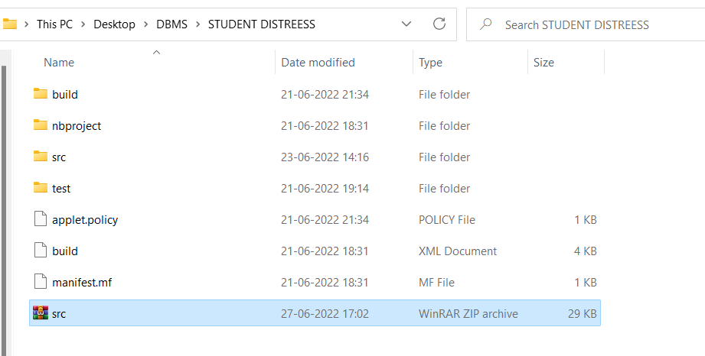

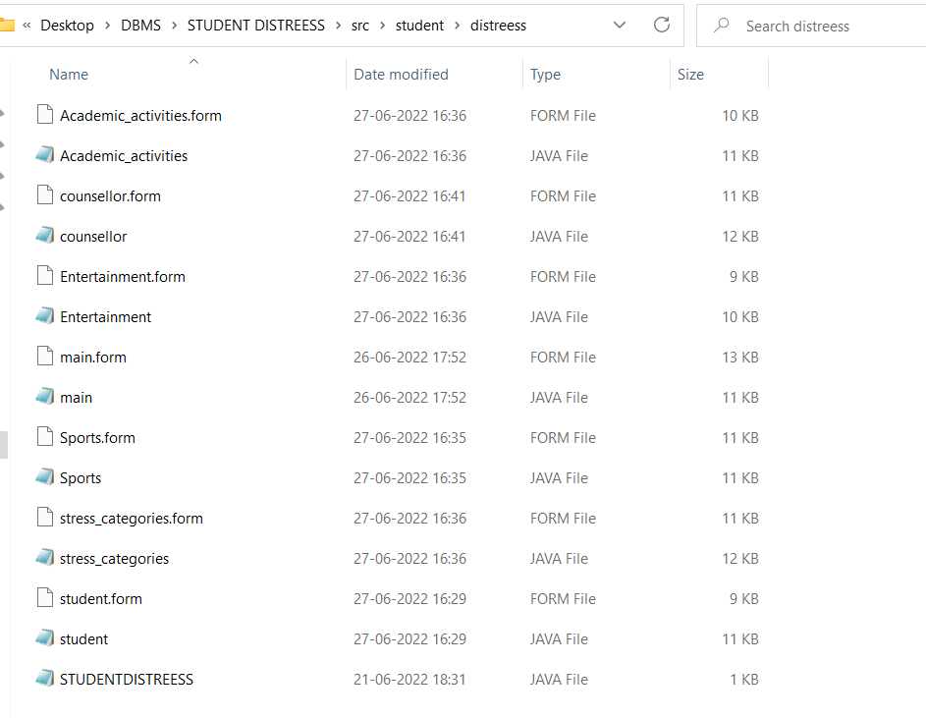

**Testing**

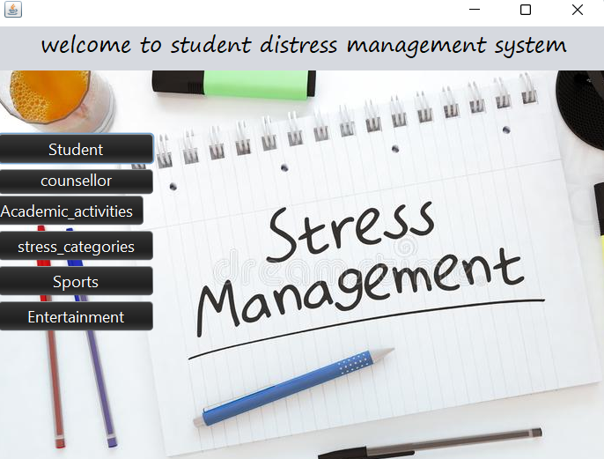

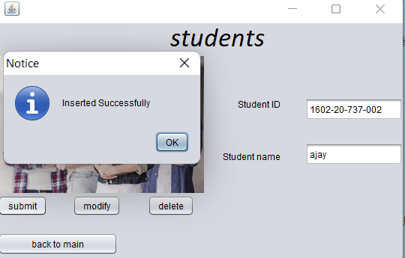

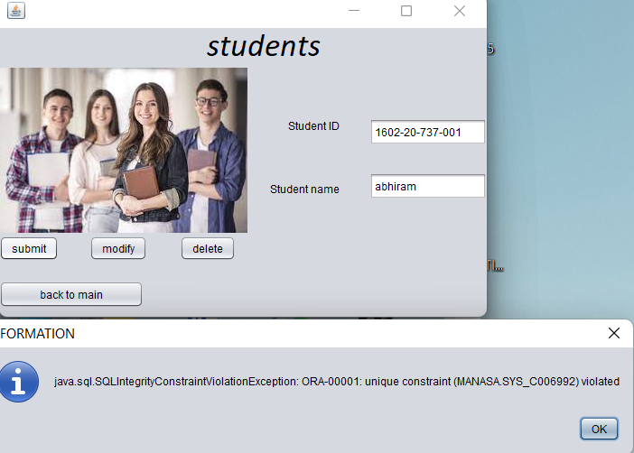

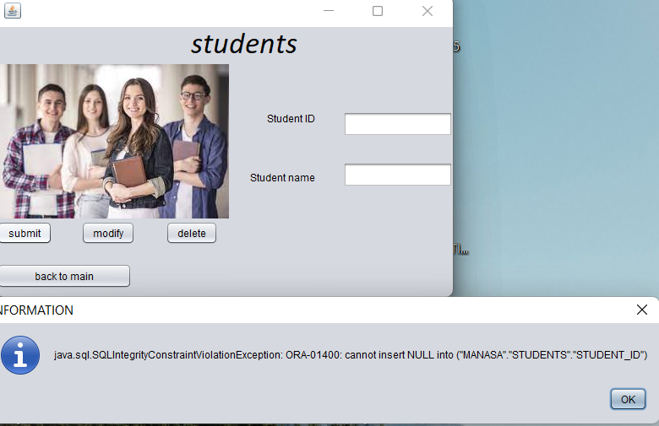

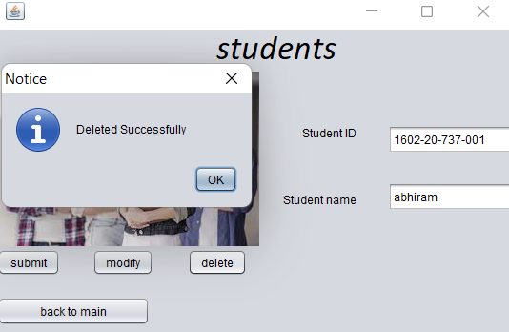

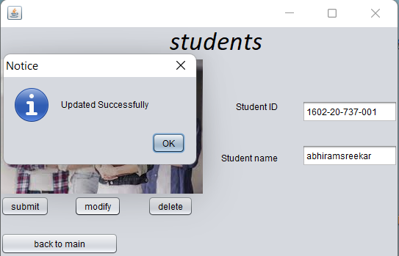

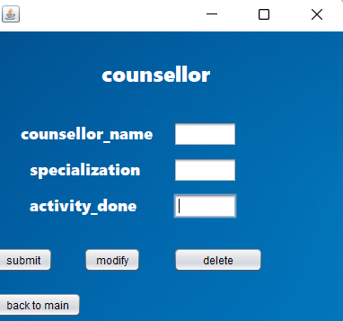

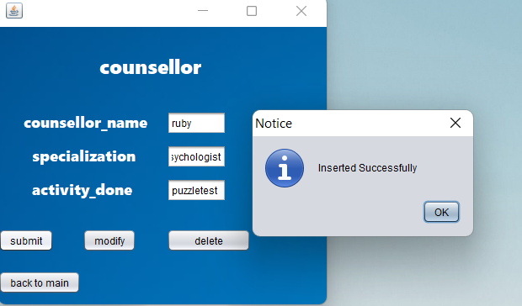

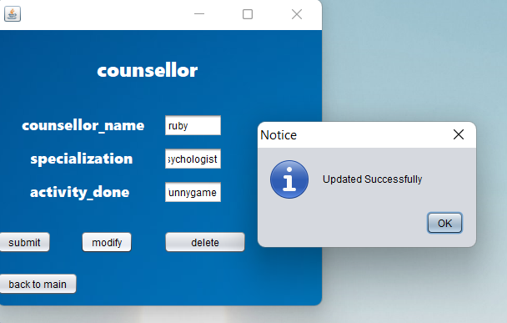

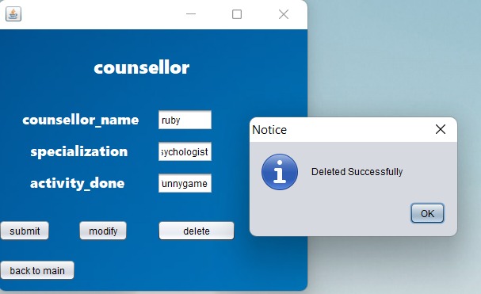

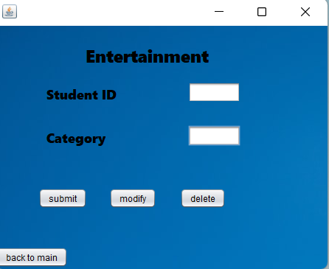

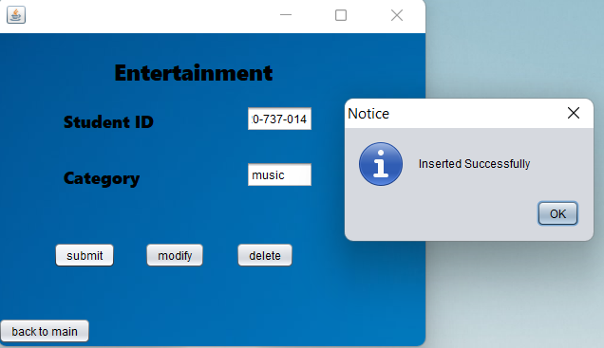

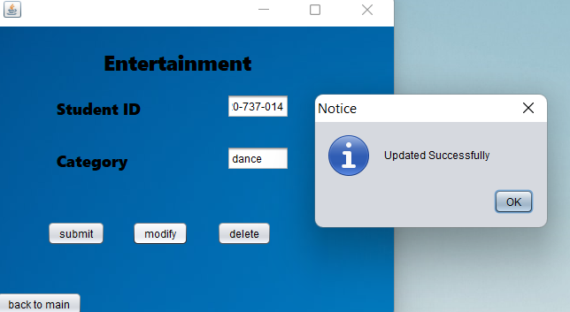

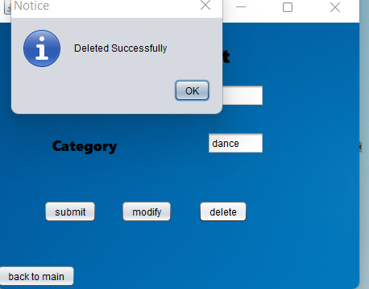

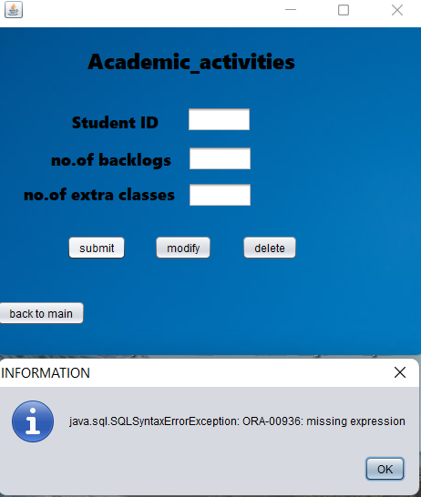

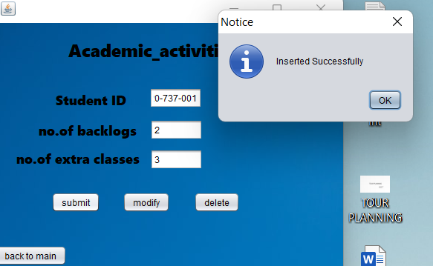

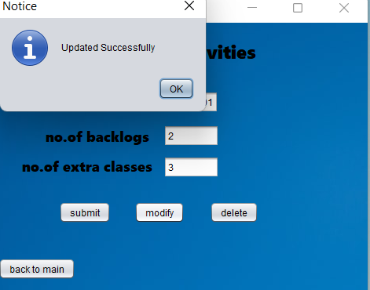

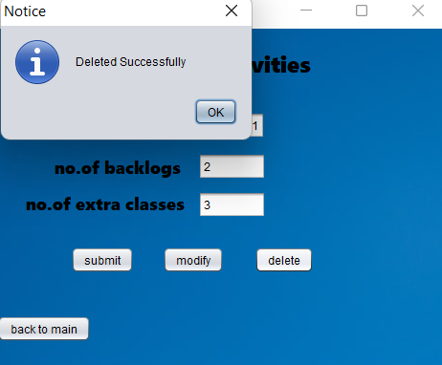

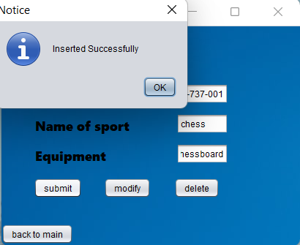

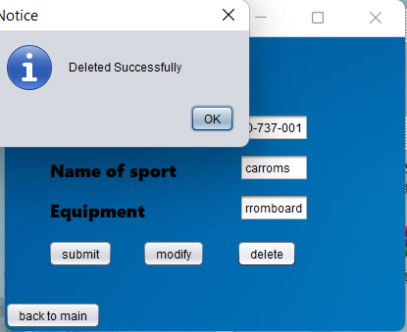

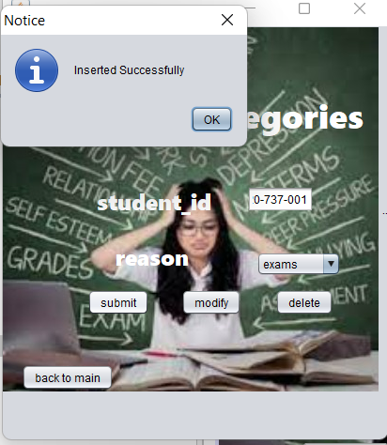

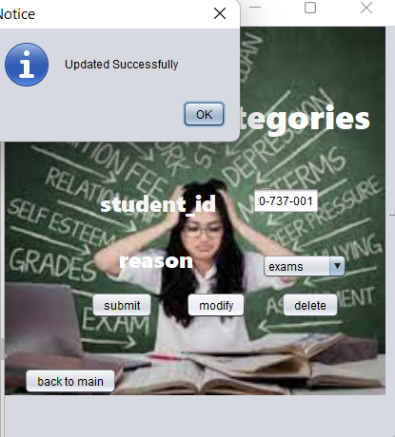

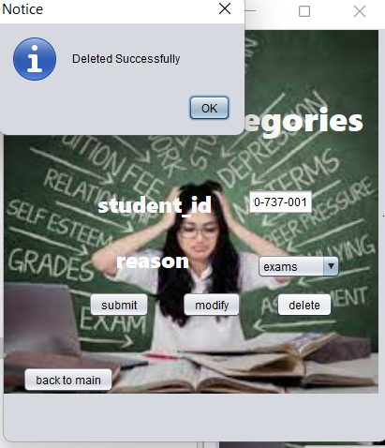

**RESULTS**

I have successfully completed the mini-project ***“Student Distress Management System”*** .

## DISCUSSION AND FUTURE WORK

This project contains the system that manages the stress among students.

Main aim of the project is to identify the stress among the students and control them by taking measures. Future scope would be to make the UI more appealing by using graphics. We can also think of including a feedback system to allow the users to leave their valuable feedback after using this app. Making this feedback to be publicly viewable, would attract many more users to use this app.

## REFERENCES

* <https://docs.oracle.com/javase/7/docs/api/>
* <https://www.javatpoint.com/java-swing>
* <https://stackoverflow.com/>